LUXURY STAY HOTEL MANAGEMENT SYSTEM

LUXURY STAY HOTEL MANAGEMENT SYSTEM
FACULTY; SIR REHAN KAPAYA BATCH CODE; AI-202408B
COURSE; HDSE II

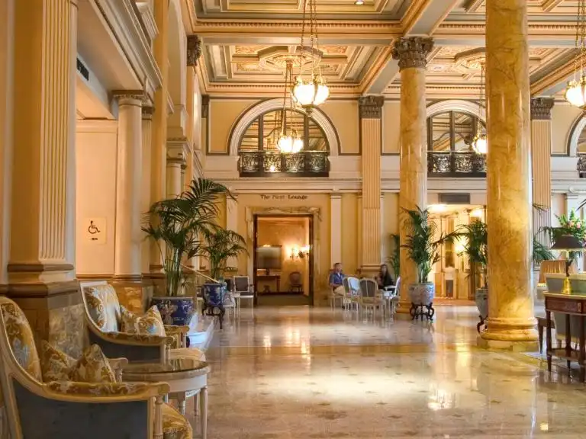

“Where Luxury Meets Comfort...”

CERTIFICATE OF COMPLETION

STUDENT ID | NAME
1596275 | M. RAYAN ASIF
1597553 | NOMAN ALI
1598708 | ABDUL KAREEM
1599841 | M. MUJTABA HYDER

This is to certify that the students of APTECH COMPUTER EDUCATION have successfully completed the E-Project [LUXURY STAY HOTEL MANAGEMENT SYSTEM]. The project has been developed as a part of the curriculum requirements for the course [HDSE II]. This project involves the development of a web-based application for managing hotel services and operations, covering Room Management, User Management, Booking Management, Service Management, Feedback Management, and Admin Management, while providing a seamless and user-friendly environment for both customers and administrators. The system has been developed using React.js for the frontend, Node.js and Express.js for the backend, and MongoDB as the database, with Mongoose used for database interaction. The application also implements authentication and role-based access control to provide secure and appropriate access for customers and administrators.

Sr. No. | Table Of Content | Page No.
1. | Problem Definition & Solution | 3
2. | Customer Requirement Specification (CRS) | 3
3. | Project Plan (Timeline) | 4
4. | Data Flow Diagram | 5
5. | Flowchart | 6
6. | E-R Diagrams (Database Design) | 7
7. | Interface Design Document (Screenshots) | 7
8. | Final Check List | 14

|Problem Statement

"Luxury Stay Hospitality", a high-end hotel chain known for its exceptional service and luxurious accommodation. With a network of hotels in various locations, Luxury Stay aims to
revolutionize its operational efficiency by implementing cutting-edge Hotel Management
System (HMS). Luxury Stay envisions a modern, scalable, and user-friendly Hotel Management System to transform its operations. The system will streamline workflows, enhance guest experiences, and provide insightful data for strategic decision-making.

Functional Requirements

User Management:
Admin Dashboard: An admin panel to manage user roles and permissions.
Staff Profiles: Ability to create, modify, and deactivate staff accounts with different access levels (manager, receptionist, housekeeping, etc.).

Guest Profiles: Creation and management of guest profiles with details like personal
information, contact, preferences, etc.

Room Management:
Room Inventory: Maintain a comprehensive inventory of rooms with details on room types,
availability, status (cleaning, occupied, available), and pricing.
Room Booking: Allow staff to reserve rooms, check availability, assign rooms to guests, and
manage bookings efficiently.
Room Status Updates: Enable real-time updates on room status (cleaning, maintenance, vacant, occupied) for better coordination among staff.

Reservation and Check-in/out:
Reservation System: Facilitate booking management, allowing guests to make reservations
online or through staff, providing confirmation details.
Check-in/Check-out: Smooth check-in and check-out processes with automated procedures for room allocation, key issuance, billing, and updating room status.
Billing and Invoicing:
Billing System: Generate accurate bills based on room rates, additional services (food, laundry,etc.), and duration of stay.
Invoicing: Provide guests with detailed invoices that can be printed or emailed, including
breakdowns of charges.

Housekeeping and Maintenance:
Housekeeping Management: Allow housekeeping staff to view room status, schedule cleaning tasks, mark tasks as completed, and report maintenance issues.
Maintenance Requests: Enable guests or staff to report maintenance issues and track their
resolution status.
Reporting and Analytics:
Reporting Dashboard: Provide management with insights via customizable reports on
occupancy rates, revenue, guest feedback, etc.
Analytics: Utilize data analytics to forecast demand, optimize pricing, and improve service
offerings.
Security and Compliance:
User Authentication: Implement secure login/logout mechanisms for staff and guests with role-based access control.
Feedback and Guest Services:
Feedback Mechanism: Provide a way for guests to leave feedback and ratings, helping in
improving services.
Additional Services: Allow guests to request additional services like room service, wake-up calls, transportation, etc.
System Administration:
System Settings: Admin controls for system configurations, including setting room rates,
defining policies, managing taxes, etc.
System Notifications: Alerts and notifications for staff regarding bookings, maintenance
requests, and other critical updates.
.

|Project Timeline

Phase | Activity | Status
1 | Requirement Analysis | COMPLETED
2 | Database Design (ER - Diagram) | COMPLETED
3 | Data Flow Diagram | COMPLETED
4 | Flowchart | COMPLETED
5 | UI/UX Design & Frontend Development | COMPLETED
6 | Testing & Debugging | COMPLETED
7 | Room, Booking & Service Management | COMPLETED
8 | Feedback & User Management | COMPLETED
9 | Documentation | COMPLETED

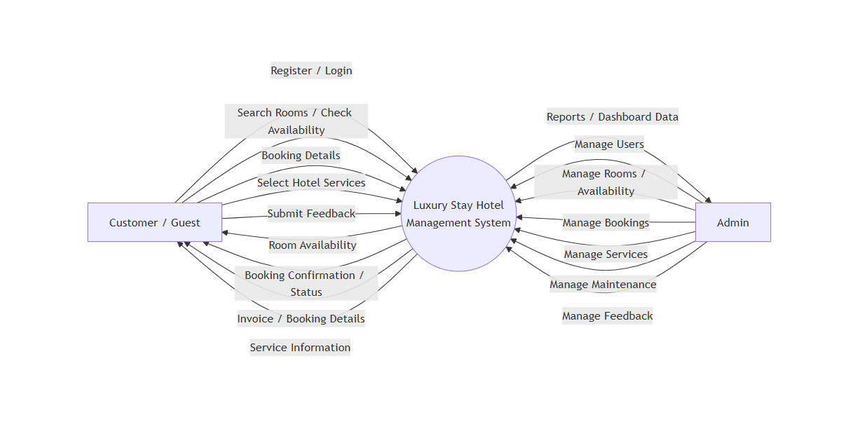
|Data Flow Diagram

Figure 1.1: Data Flow Diagram (Context Diagram)
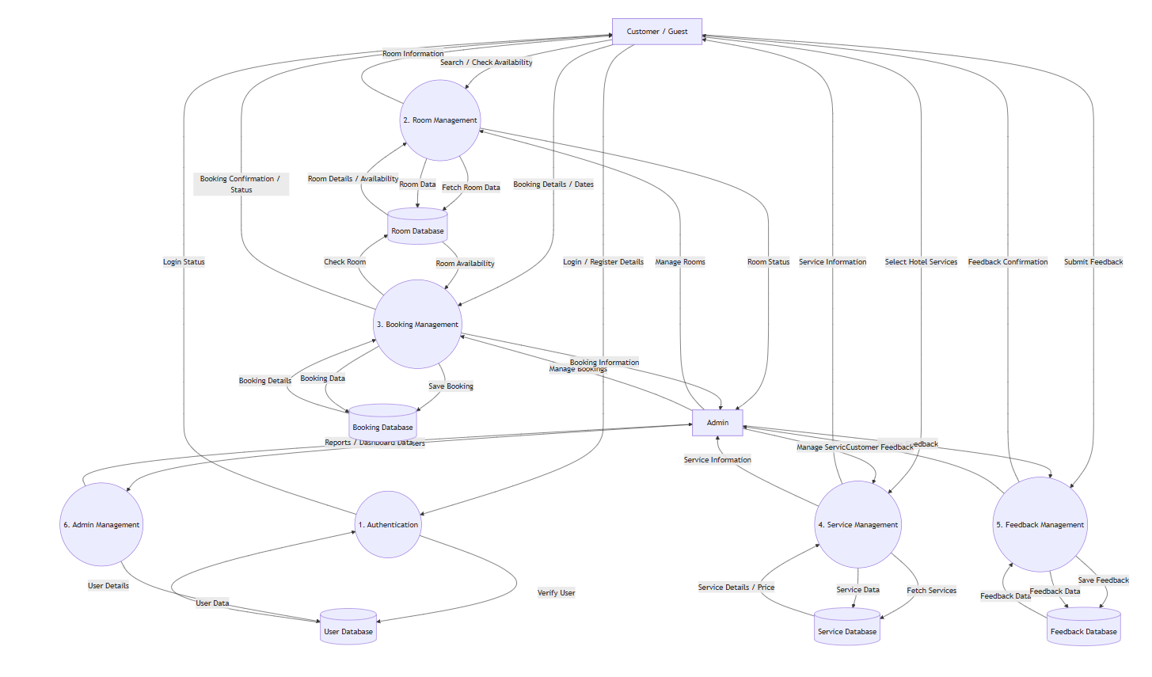

Figure 1.2: Data Flow Diagram (Detailed Diagram)

|Flow Chart
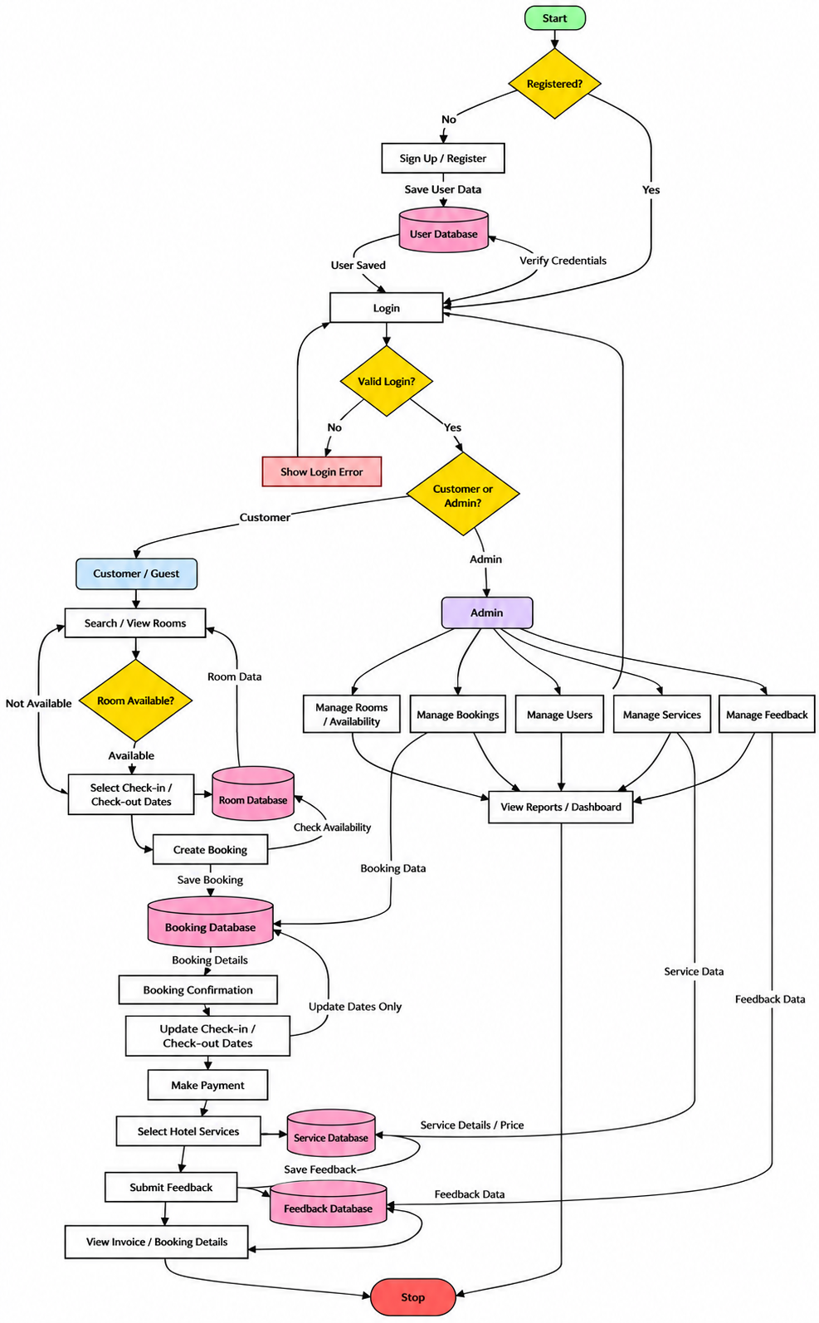

|ER – Diagram

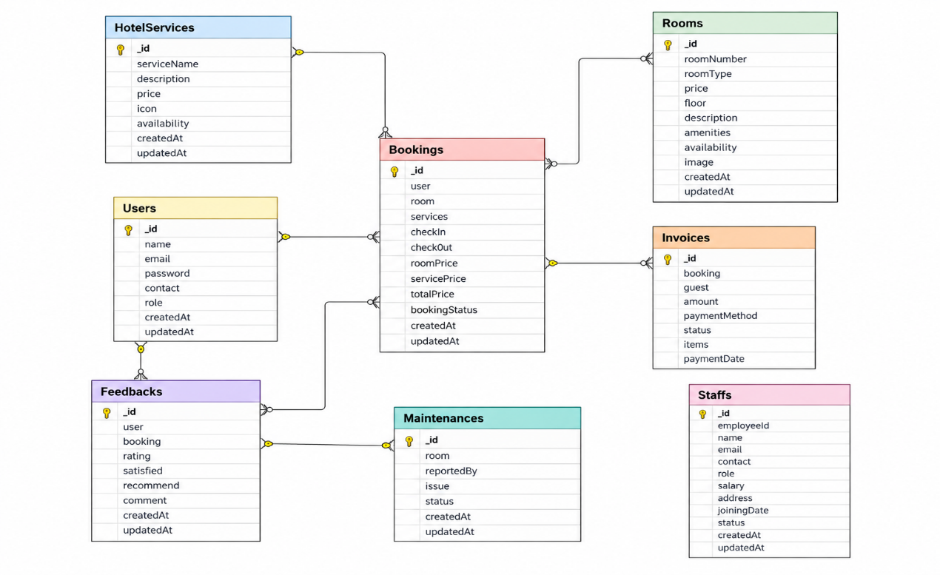

| Interface Design Document (Screenshots)
- Homepage


- Login Page

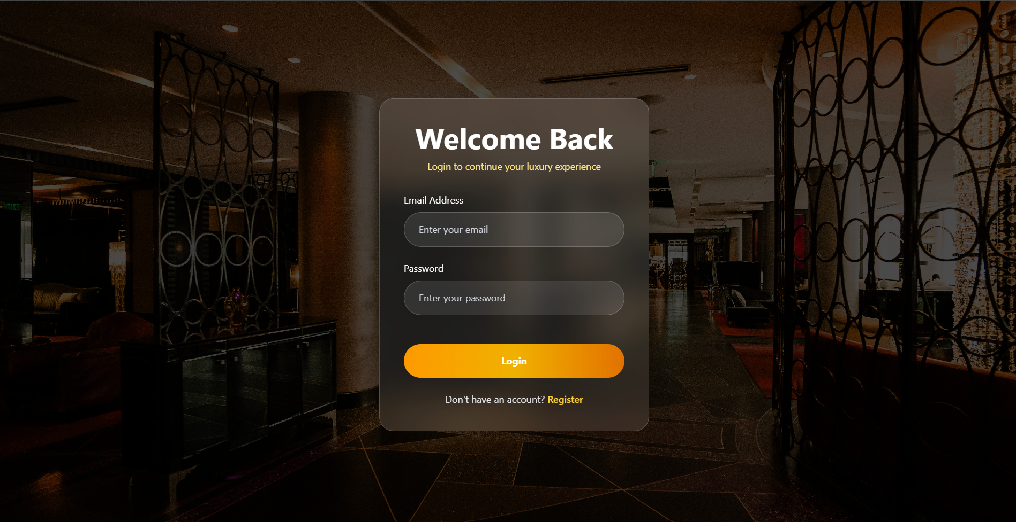

- Register Page

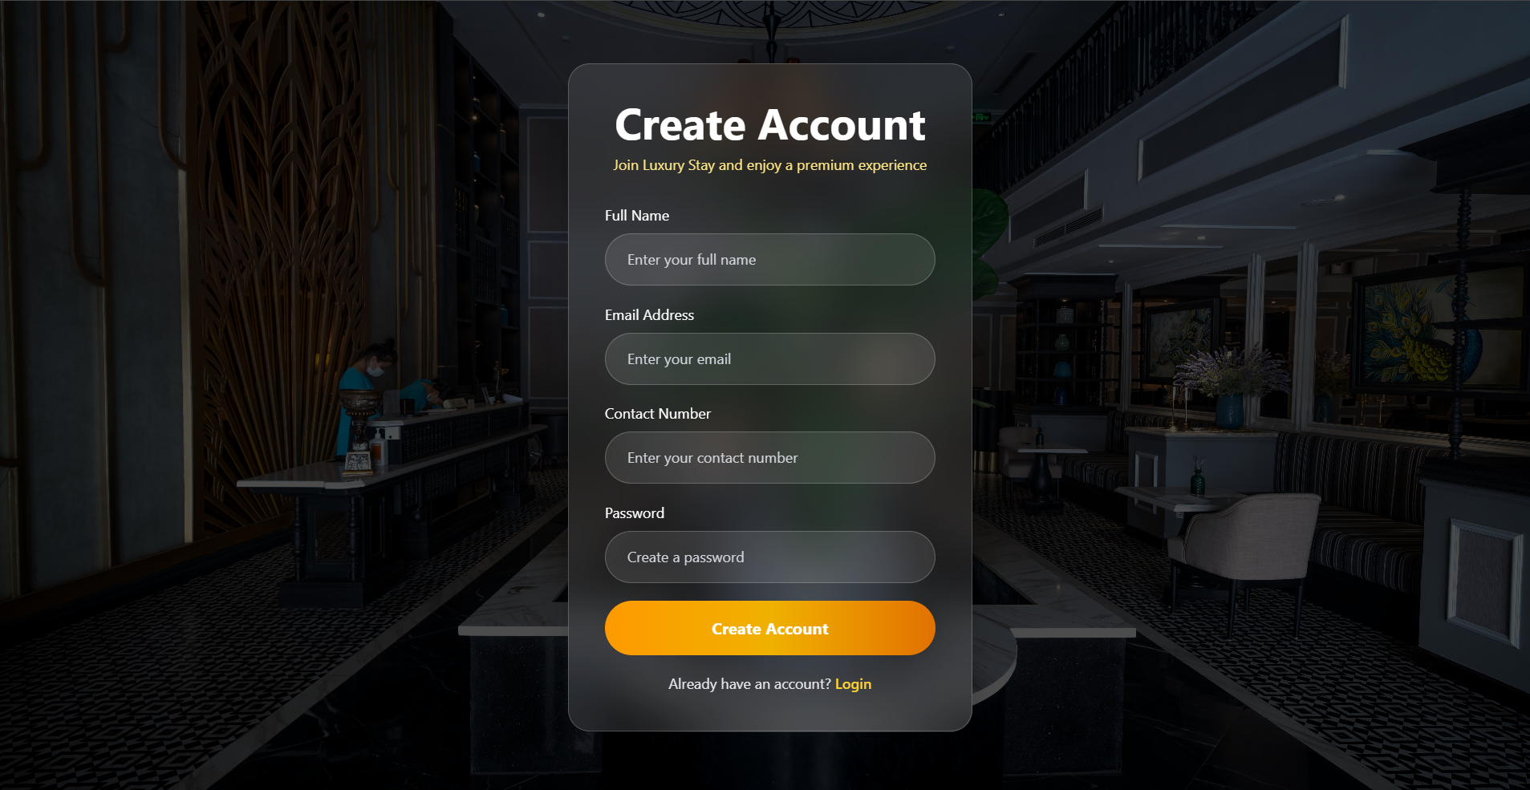
- Room Page

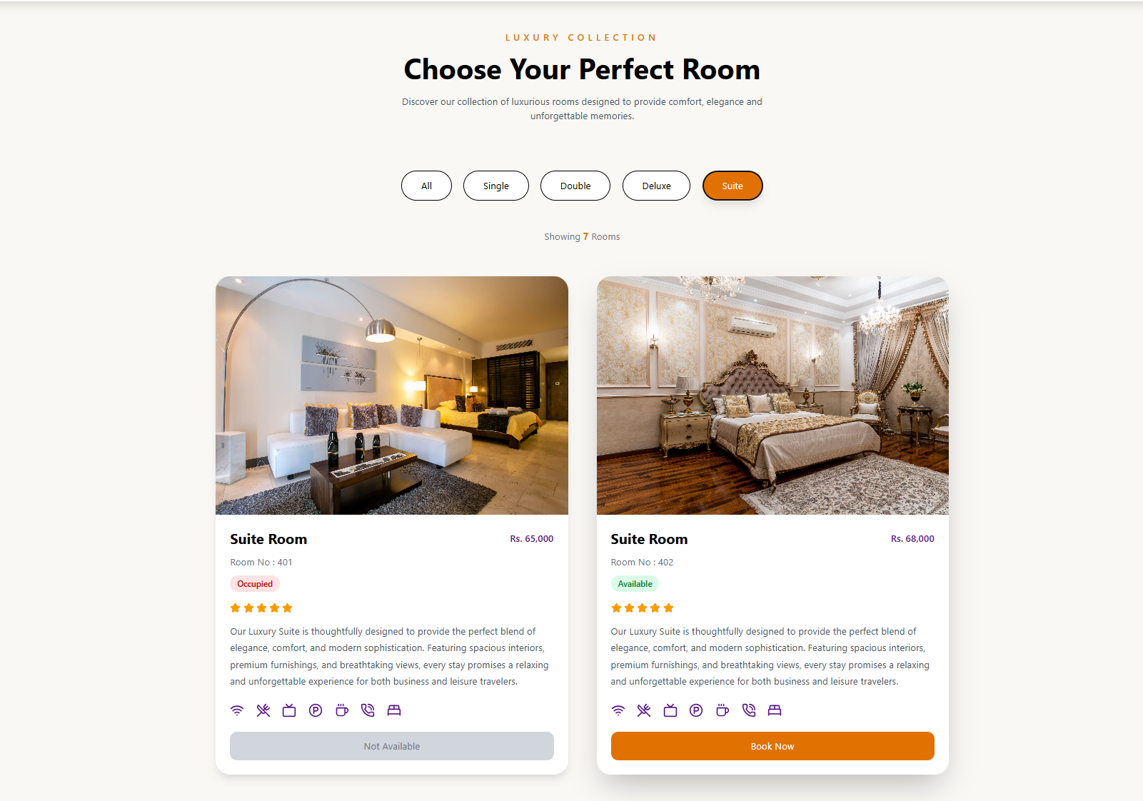
- Services Page
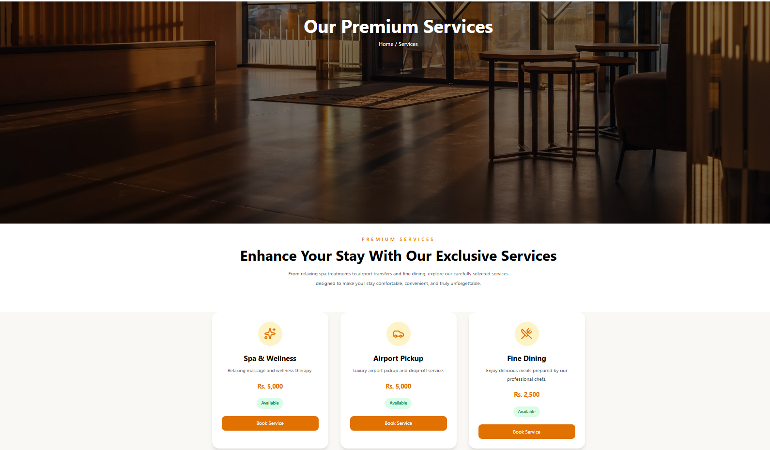
- ADMIN DASHBOARD
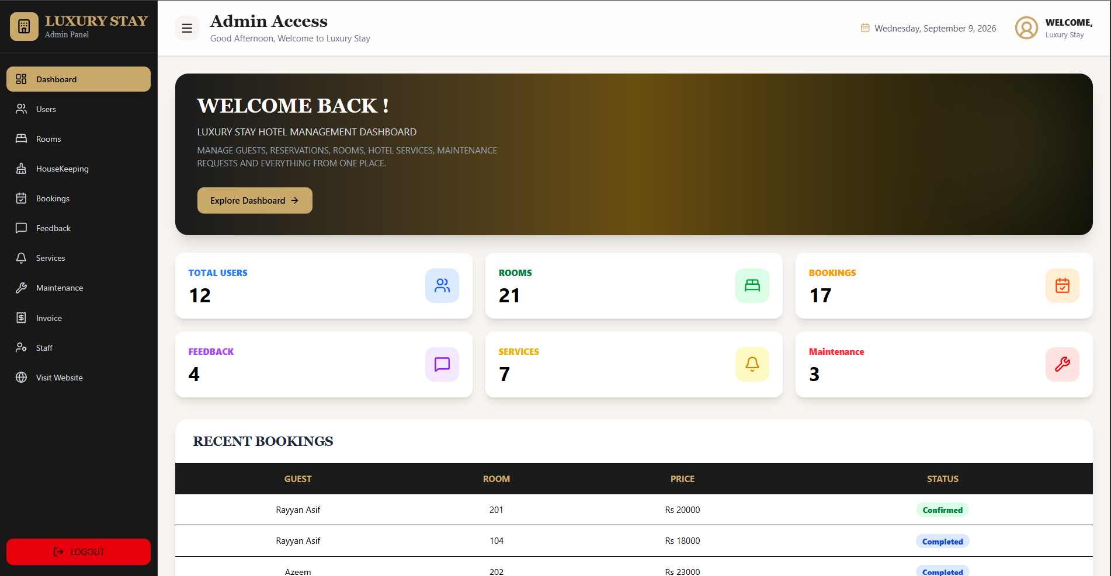

- User Management

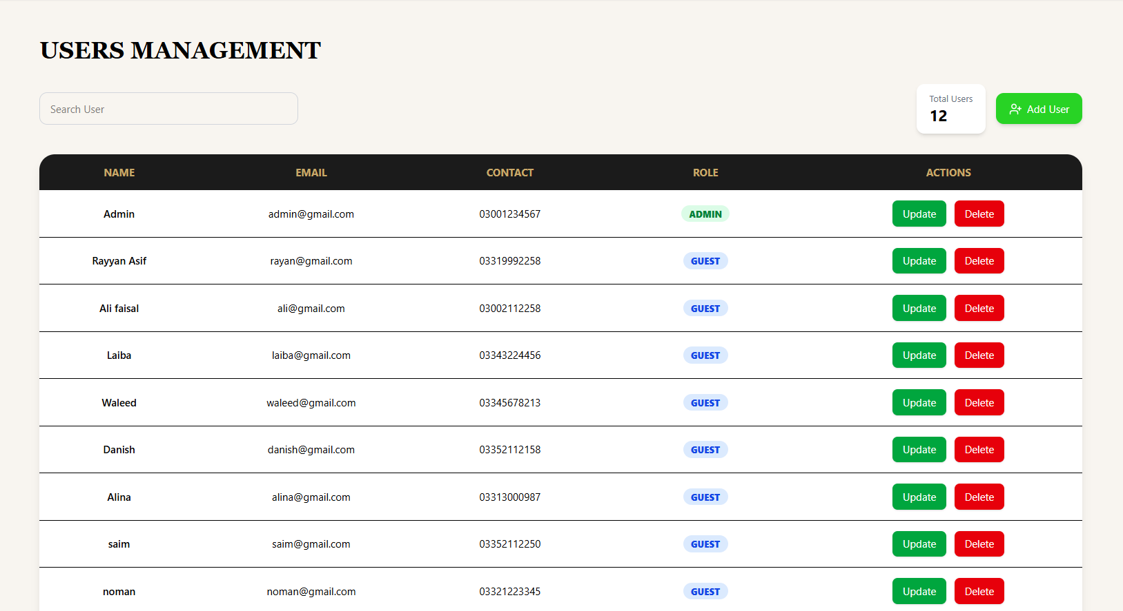

- Room Management (Admin)

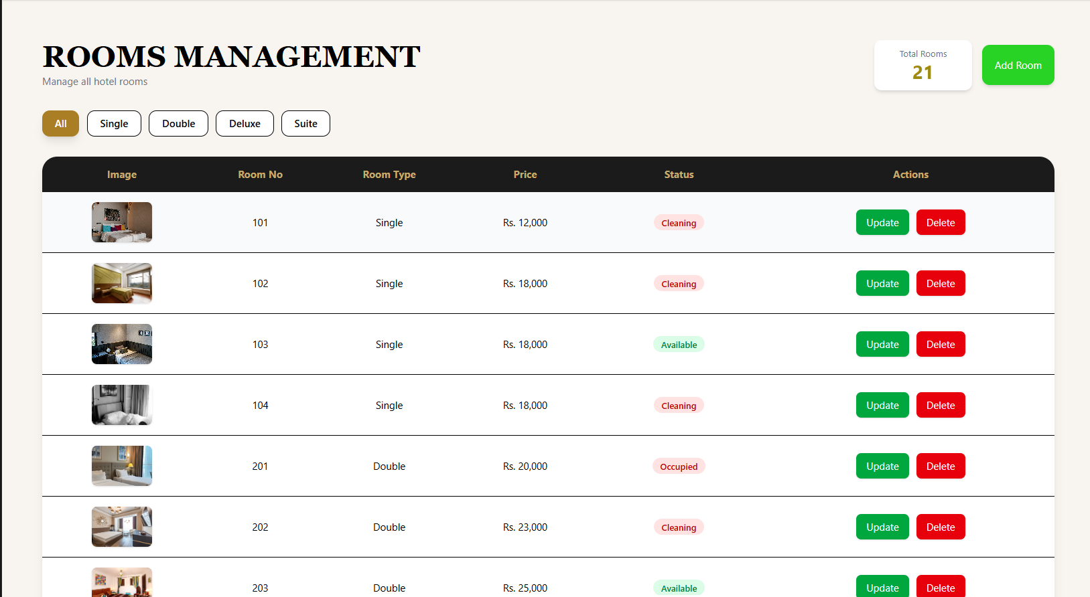

- Invoice Generation

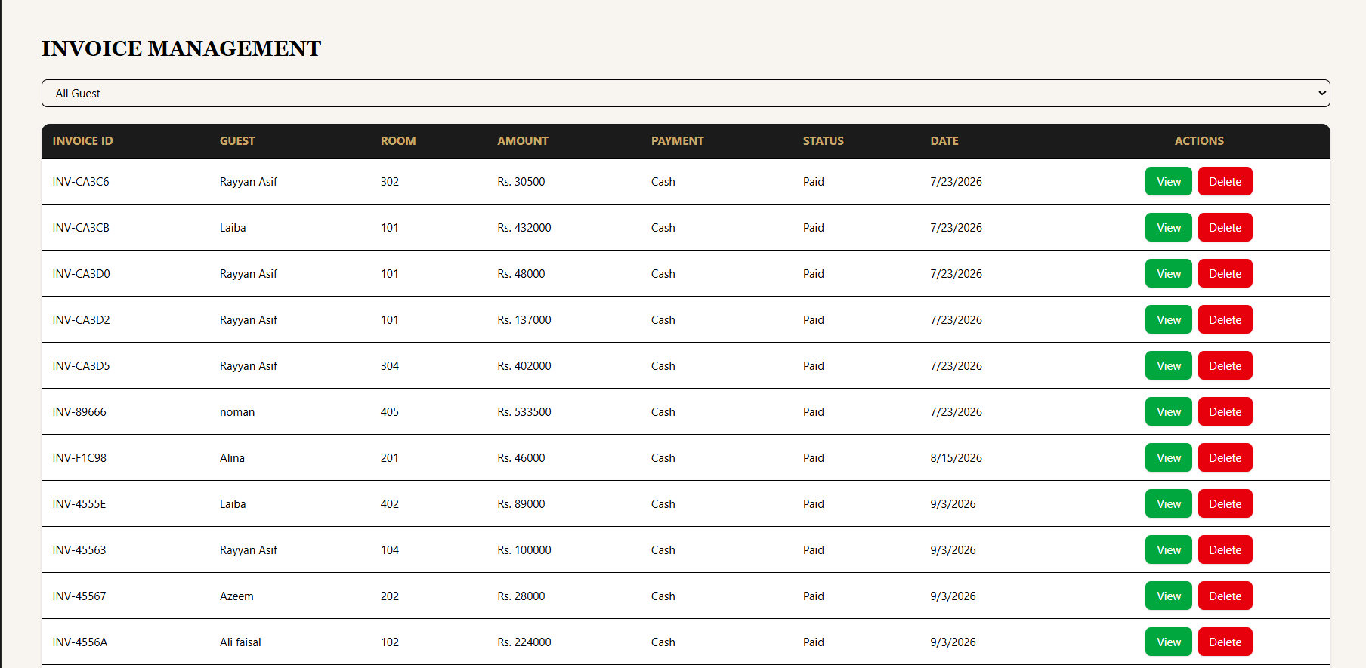

- Booking Management

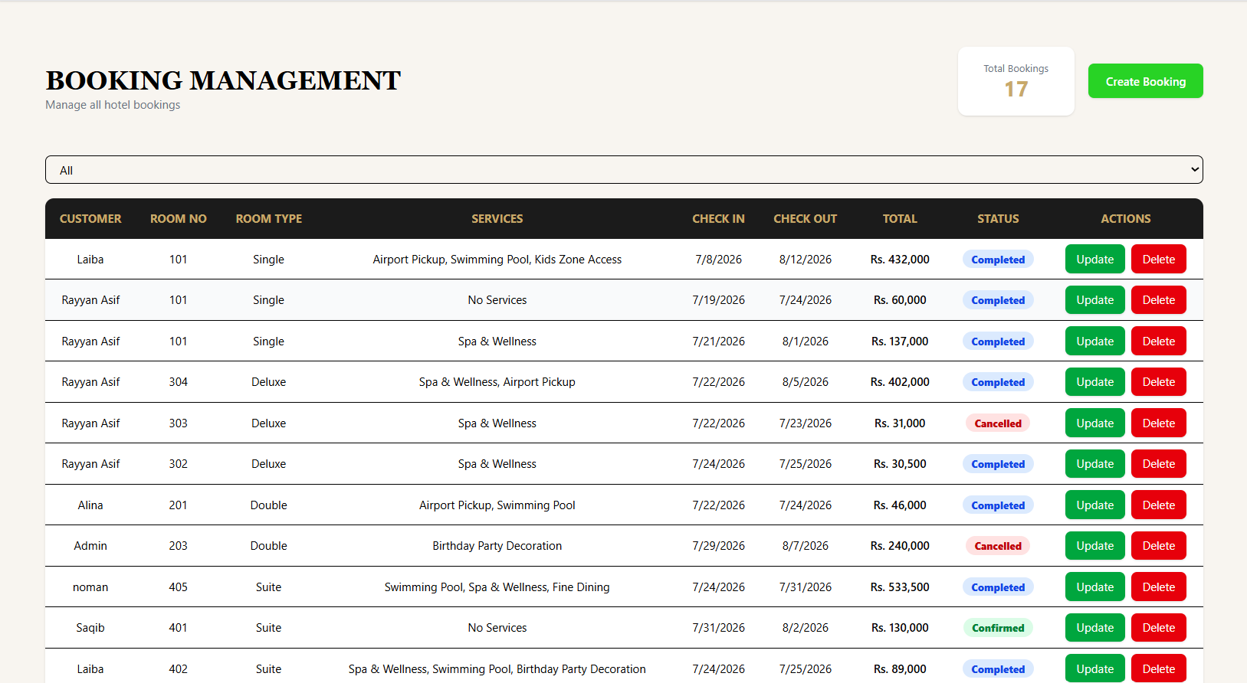

- Staff Management

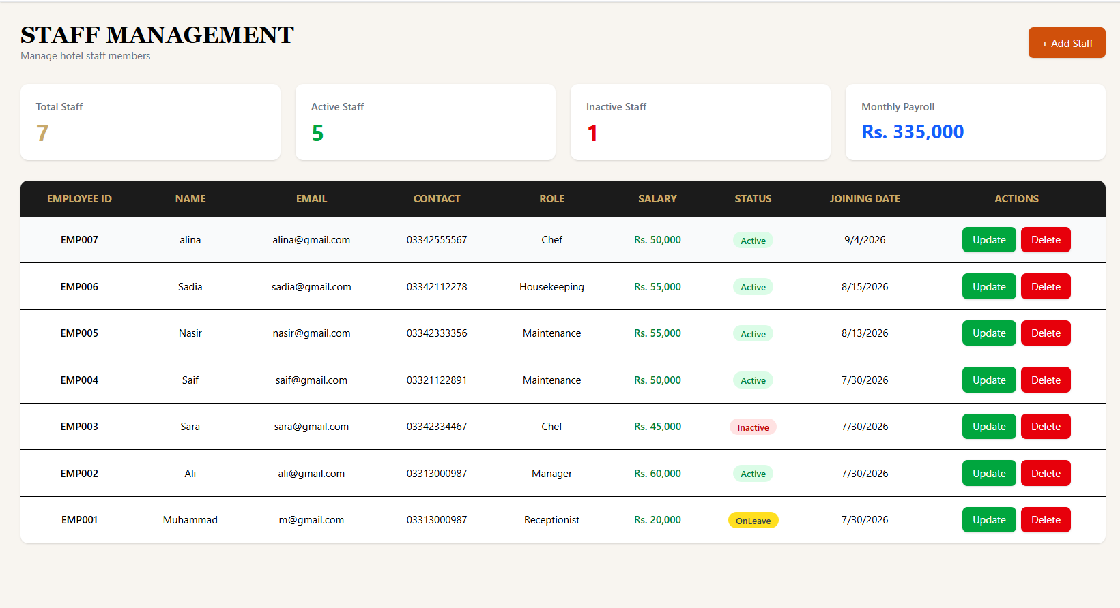
CHECKLIST

S/No | Features | Status
I. | User Registration (Register new user with basic info.) | Completed
II. | Admin Rights (Full control to Edit, View, Delete data.) | Completed
III. | Invoice Generation (Generate Bill/Invoice for bookings and services.) | Completed
IV. | Service Types (Users can select available hotel services such as Spa & Wellness, while admin can add, edit, and manage services and prices.) | Completed
V. | Booking Management (Users can search available rooms and create bookings by selecting check-in and check-out dates.) | Completed
VI. | Feedback Management (Users can submit ratings, satisfaction, recommendations, and comments after their stay.) | Completed
VII. | Maintenance Management (Admin can record room maintenance issues and update their status, such as Pending, In Progress, or Completed.) | Completed
VIII. | Room Availability (Admin can view overall system information such as total users, rooms, bookings, services, feedback, maintenance records, and booking income.) | Completed
IX. | Dashboard & Reports (Notifications on status change giving updates regarding their order) | Completed

